Part 1: AI-Assisted Code Generation
Chosen problem: Create an array of five book objects (title, author, pages), then print only the books with more than 200 pages.
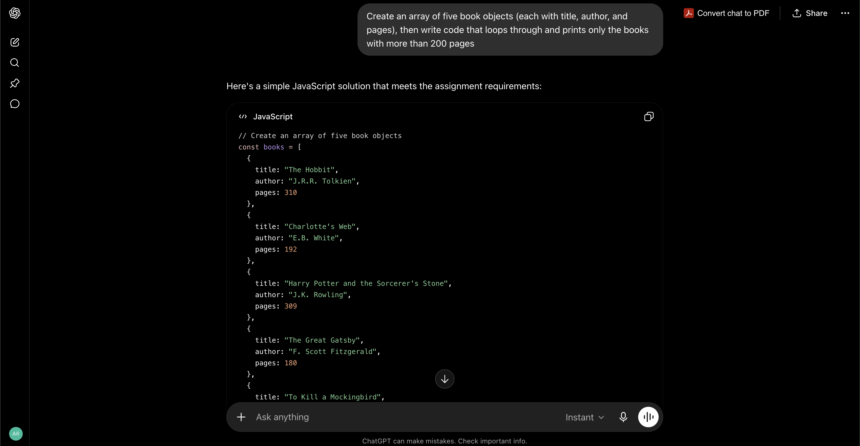
AI Conversation

Prompt given to the AI:
"Write JavaScript code that creates an array of five book objects, each with a title, author, and pages property. Then write code that loops through the array and prints only the books that have more than 200 pages, including the title, author, and page count in the output."

AI response (code): see the working version in assignment-3-compiled.js. It matched the AI's suggestion; no further fixes were needed after testing.

Reflection Questions
- How does the code access properties inside each object?
  - It uses dot notation - for example, books[i].pages and books[i].title - to reach into each object in the array and read the value stored under that property name.
- What type of loop does the code use to go through the array?
  - A standard for loop (for (let i = 0; i < books.length; i++)) that runs once for every index in the array.
- Why do we need both arrays AND objects to solve this problem?
  - The array gives us an ordered collection we can loop through - it's the list of "all books." Each object groups the related details of a single book (title, author, pages) under one variable, so we don't have to manage separate, unlinked lists for titles, authors, and page counts. Together, the array handles the collection and the object handles the structure of each item in it.

Part 2: Find the Bugs
Snippet A - Access Object Property
Bug: student[major] uses major without quotes, so JavaScript looks for a variable named major instead of the string "major". Since no such variable exists, this throws an error.
Fix: Use student["major"] (a string in the brackets), or simpler, use dot notation: student.major.

Snippet B - Add to Array
Bug: fruits[3] = "grape" only works because we happen to know the array currently has exactly 3 items. If the length were ever different, this could overwrite an existing item or leave an empty gap in the array.
Fix: Use fruits.push("grape"), which always adds to the end of the array regardless of its current length.

Snippet C - Calculate Total Price
Bug: The loop uses total = total + price, but price is never defined anywhere - it needs to come from the current cart item.
Fix: Use total = total + cart[i].price to read the price property off each object in the array.

Snippet D - Find a User
Bug: The else is inside the loop, so "Not found" prints every time an item doesn't match - not just when nothing matches after checking the whole list. Running it prints "Not found", "Found!", "Not found" instead of just "Found!".
Fix: Use a flag variable (e.g. found = true) set inside the if, and check it after the loop ends - only printing "Not found" if no match was ever found. A break can also be added once a match is found to stop looping early.

Part 3: Improve the Code
The improved version is in assignment.js, Part 3. Summary of changes and reasoning:
- Renamed a to users2 and x to activeUserNames - descriptive names make the purpose of each variable clear without needing to read the whole script first.
- Renamed the object properties n and e to name and email - single-letter properties force the reader to memorize a hidden key; full names are self-documenting.
- Replaced var with const/let - const signals the variable is never reassigned, and both avoid the confusing function-level scoping behavior of var.
- Replaced == true with === true - strict equality checks both value and type, avoiding subtle bugs that loose equality can introduce.
- Added comments above each block explaining its purpose, so the intent of the code doesn't have to be reverse-engineered later.

Part 4: Write Your Own Code
All three programs were written without AI assistance and are included in assignment-3.js, Part 4, with comments. Summary of each:
- Problem 1: An if/else if/else statement checks whether num is greater than, less than, or equal to 0, printing "positive", "negative", or "zero" accordingly.
- Problem 2: A for loop iterates through the numbers array, adding each value to total only if it's greater than 0, skipping negative numbers and zero.
- Problem 3: A for loop counts from 1 to 10, printing a line of the multiplication table for the chosen num on each pass.

